External User Manual

NQA Automated System

To:

Namibia Qualifications Authority (NQA)


From:


Green Enterprise Solutions PTY Ltd.

CONTENTS
DOCUMENT INFORMATION 3
Revision History 3
Project Information 3
1. ACCESSING THE APPLICATIONS FOR EVALUATIONS OF QUALIFICATIONS PORTAL 4
2. REGISTRATION 4
3. SIGN IN 6
4. RESET PASSWORD 7
5. LODGING AN APPLICATION 8
6. LODGING AN APPEAL 14
7. REFUNDS 19
8. DUPLICATE 21
9. PROFILE 23

DOCUMENT INFORMATION

Revision History
Version | Summary of Changes | Author
1.0 | Final Version | Wilika Shakulenga
Table 1: Revision History

Project Information
Document Name | User Manual
Client: | Namibia Qualifications Authority (NQA)
Project Title: | NQA Automated System
Start Date: | 19 March 2025
Document Submission Date | 23 April 2026
Table 2: Project Information

- ACCESSING THE APPLICATIONS FOR EVALUATIONS OF QUALIFICATIONS PORTAL
  - IMPORTANT LINKS

Production: online.namqa.org

- REGISTRATION

- Open a new window in your browser, and enter the URL:
online.namqa.org

Figure 1

- Click Register as a first-time user.

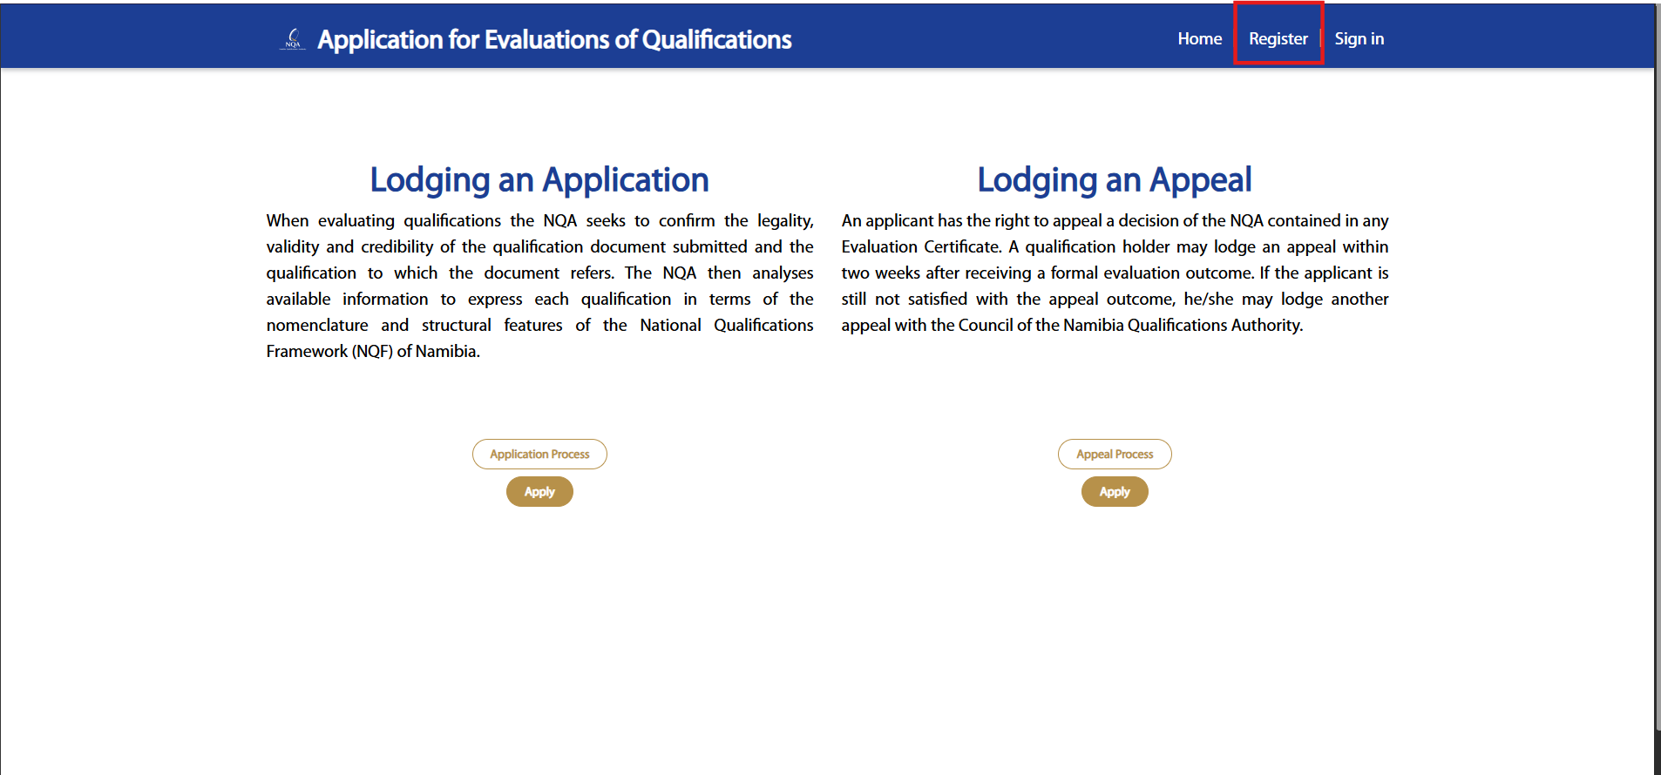
Figure 2

- Fill in the required fields and Click Submit

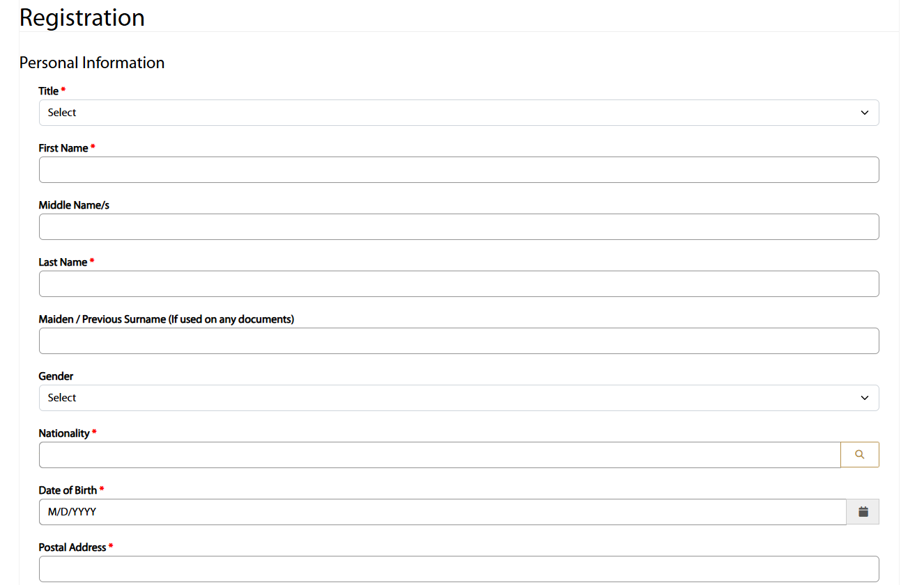
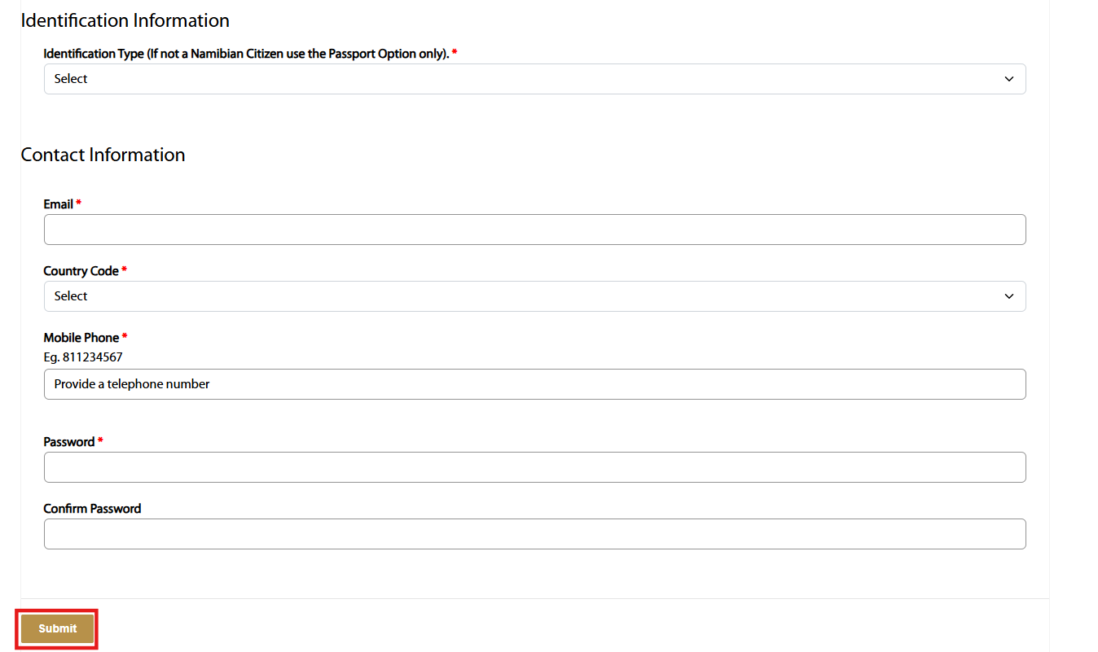
Figure 3
- SIGN IN

- After registering, it will redirect to the Homepage and then Click Sign In

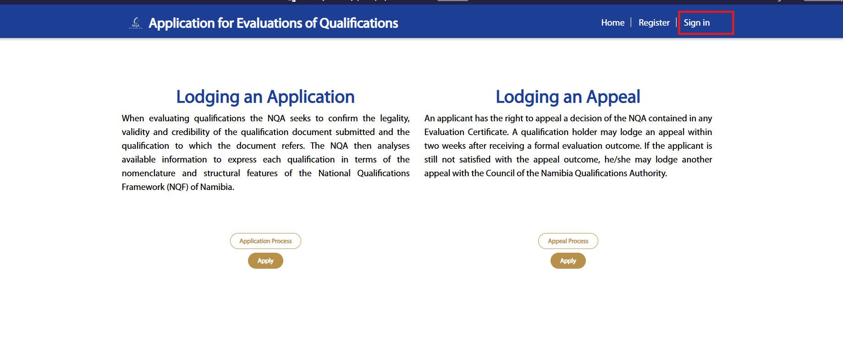
Figure 4

- Enter Username and Password. Click Sign In

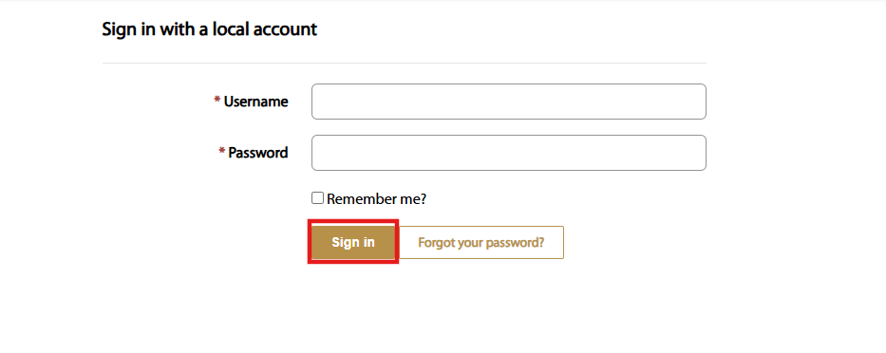
Figure 5

- RESET PASSWORD

- If you cannot remember your password, Click the Forgot your password?

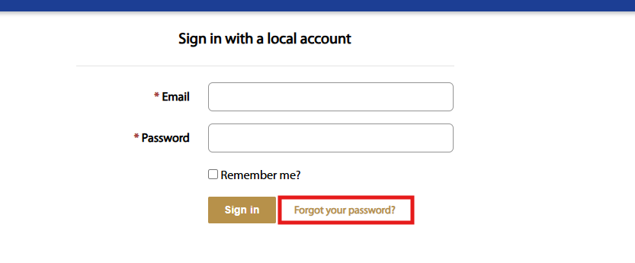
Figure 6

- Enter your registered email address in the provided field, then Click the Send button to receive a password reset link via email.

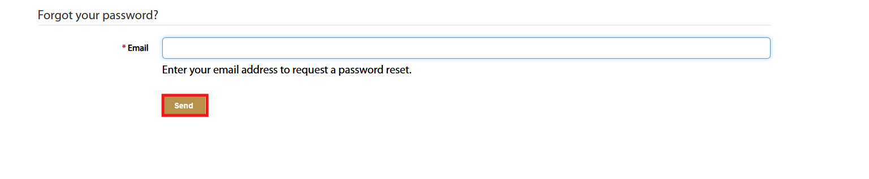
Figure 7

- Enter your new password in the “New password” field, re-enter it in the “Confirm new password” field, then Click the Reset button to update your password.

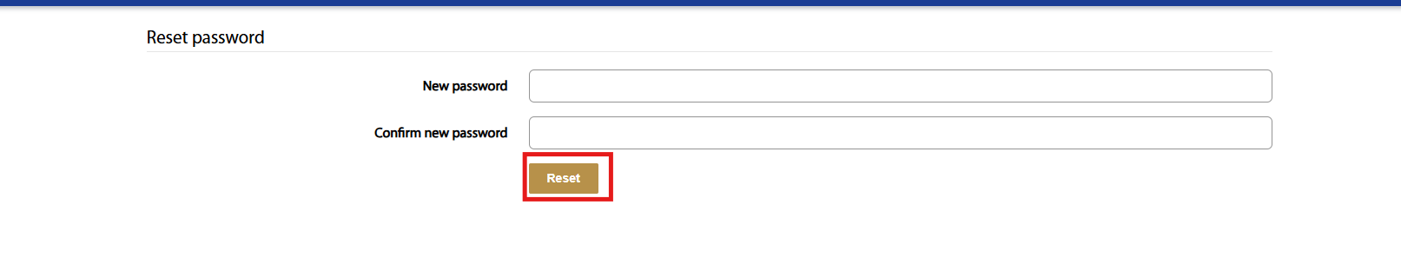
Figure 8

- LODGING AN APPLICATION
  - APPLICATION PROCESS

- Click the Application Process before applying

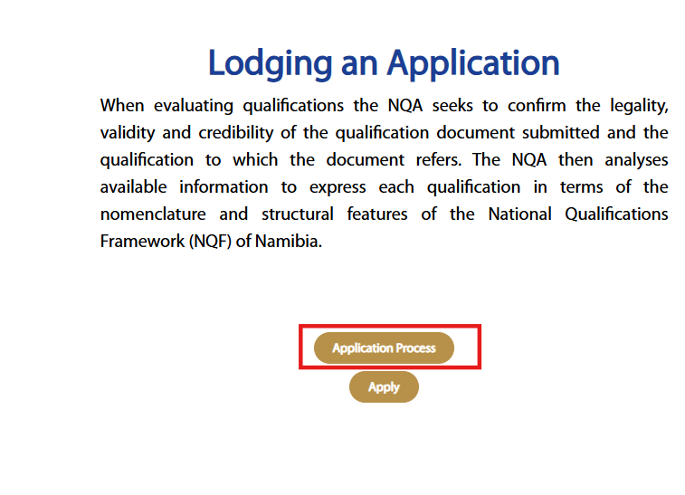
Figure 9

- View the information about the Application Process

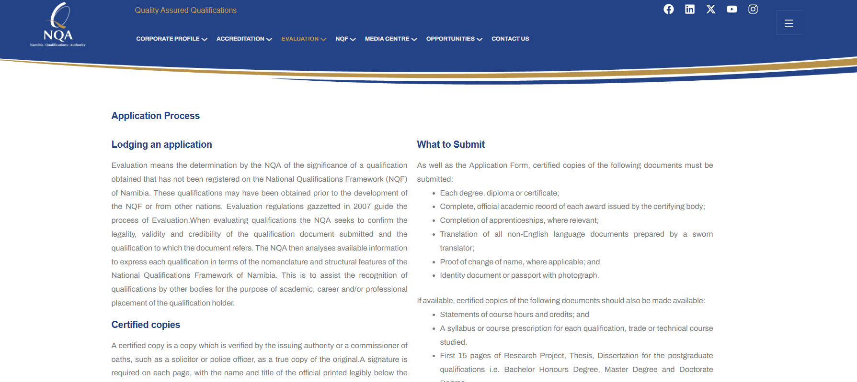
Figure 10



  - APPLICATION FORM

- Click Apply to go to the application form

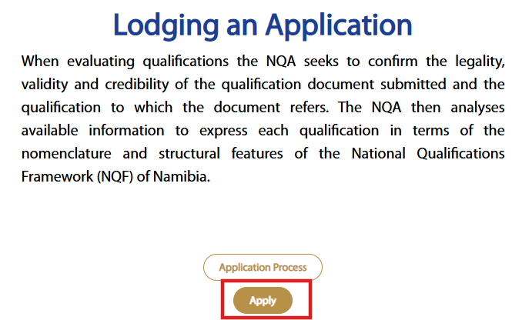
Figure 11

- Fill in the required fields and Click Submit

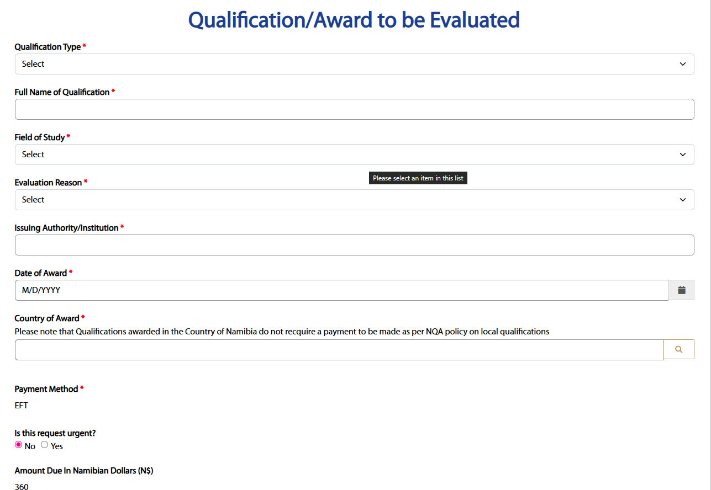
Figure 12

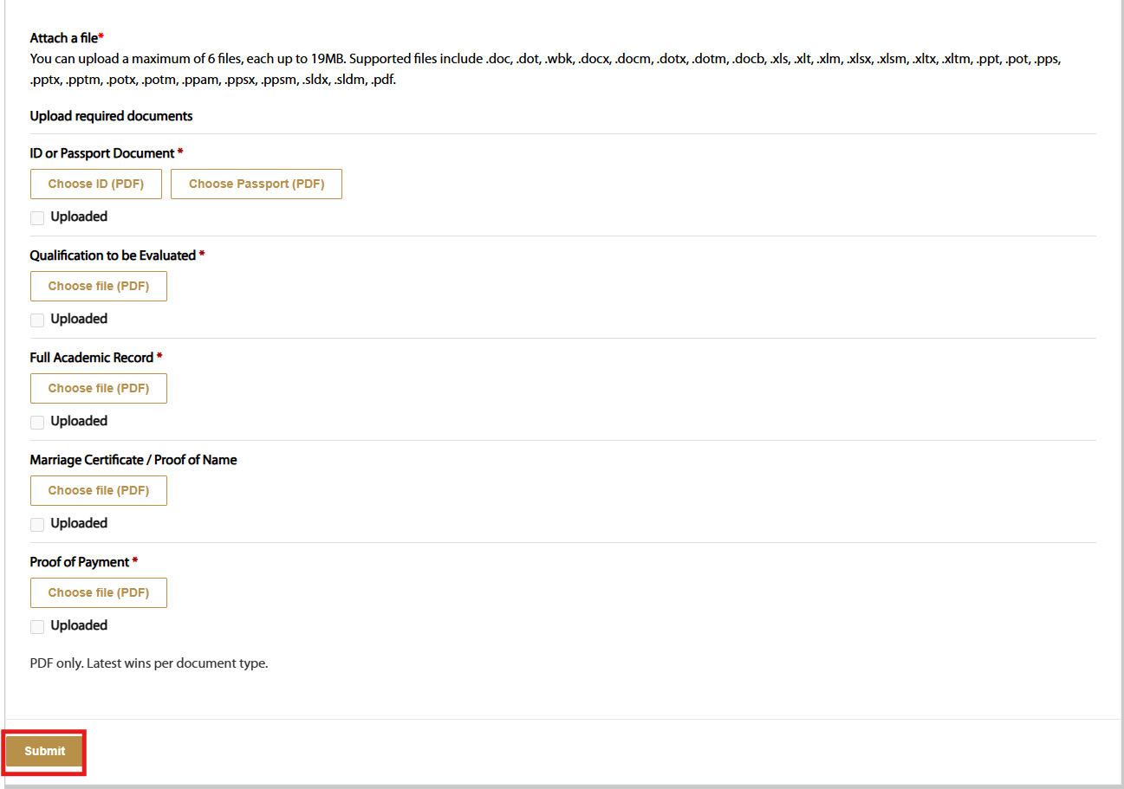
Figure 13

- After submitting, it will pop up that “Submission Completed Successfully”.


Figure 14

  - MY APPLICATIONS

- Click the My application dropdown and Select Evaluation

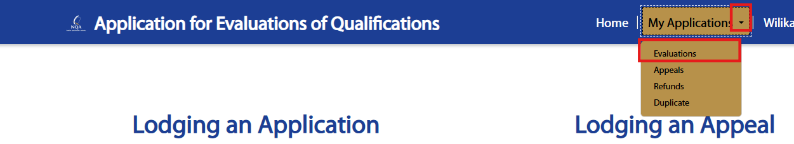
Figure 15

- View the Application status and click the View icon

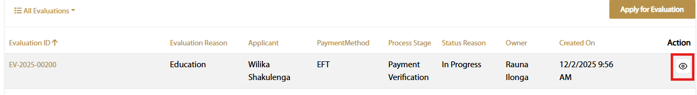
Figure 16

- View the Preview information

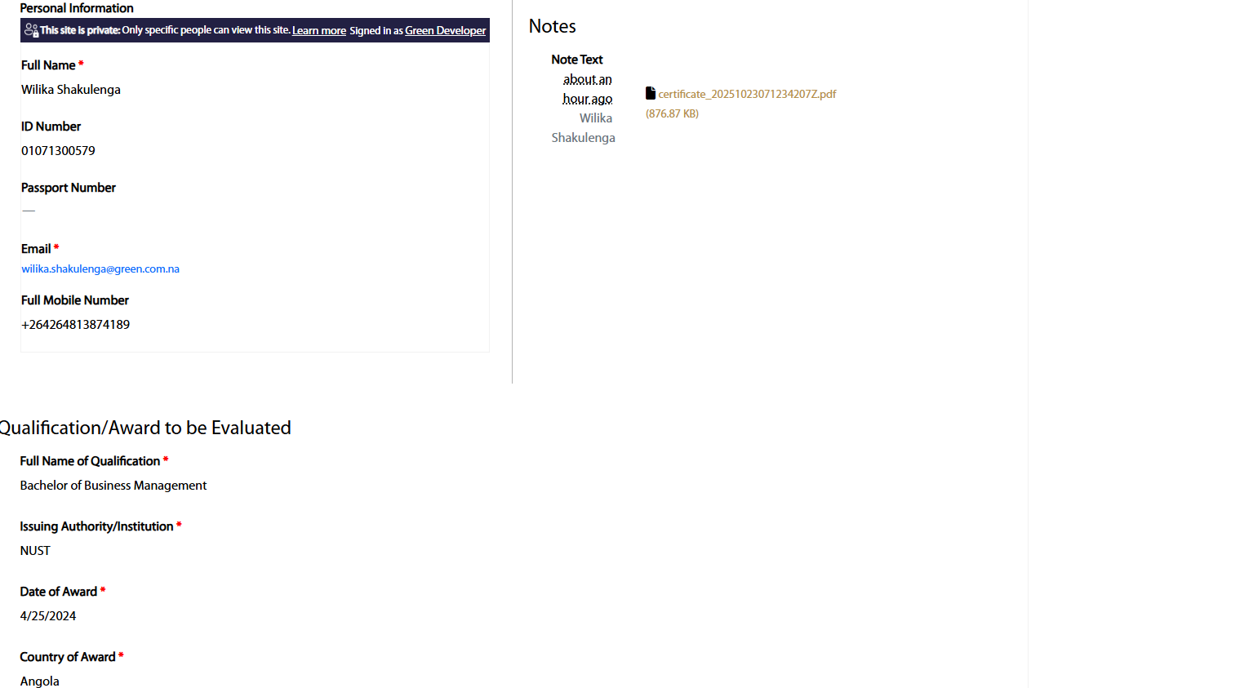
Figure 17

- A Pencil Icon will appear to resubmit when receiving a shortcoming. Click the Pencil icon

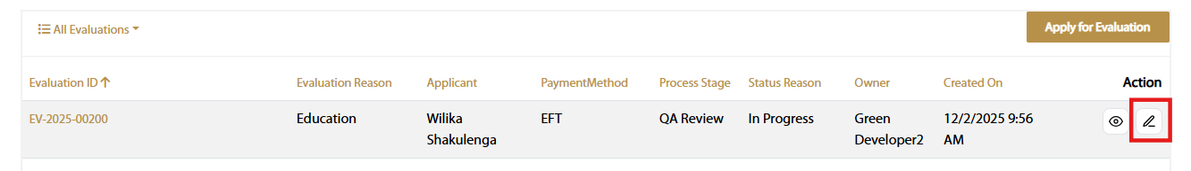
Figure 18

- View the Uploaded Attachments. Click Upload to attach the requested documents, and then Click Submit

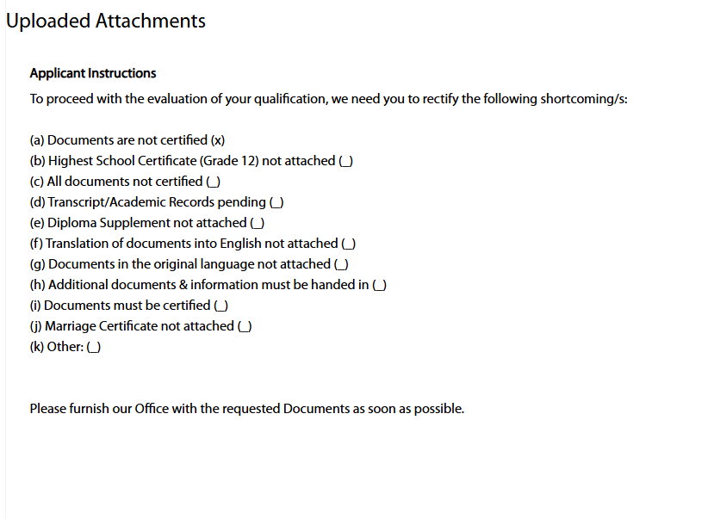
Figure 19

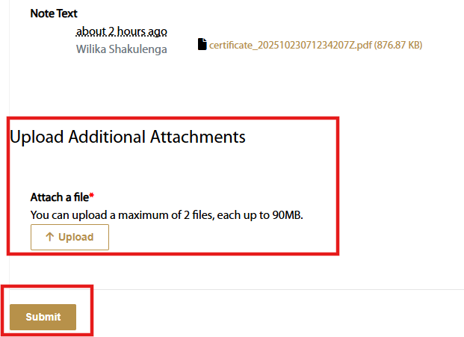
Figure 20

- After submitting, it will pop up that “Submission Completed Successfully”.

Figure 21

- A Download Icon will appear to generate the E-Certificate when receiving an Approval Email. Click the Download icon

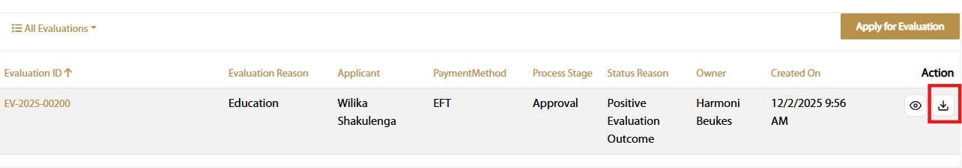
Figure 22

- Click the drop-down arrow to select the Evaluation category (In Progress Evaluations, Approved Evaluations, or Rejected Evaluations).”

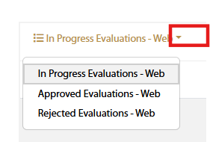
Figure 23

- LODGING AN APPEAL
  - APPEAL PROCESS

- Click the Appeal Process before applying

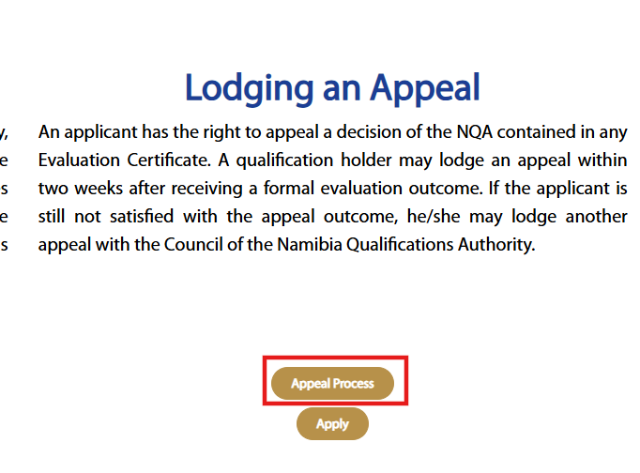
Figure 24

- View the information about the Appeal Process

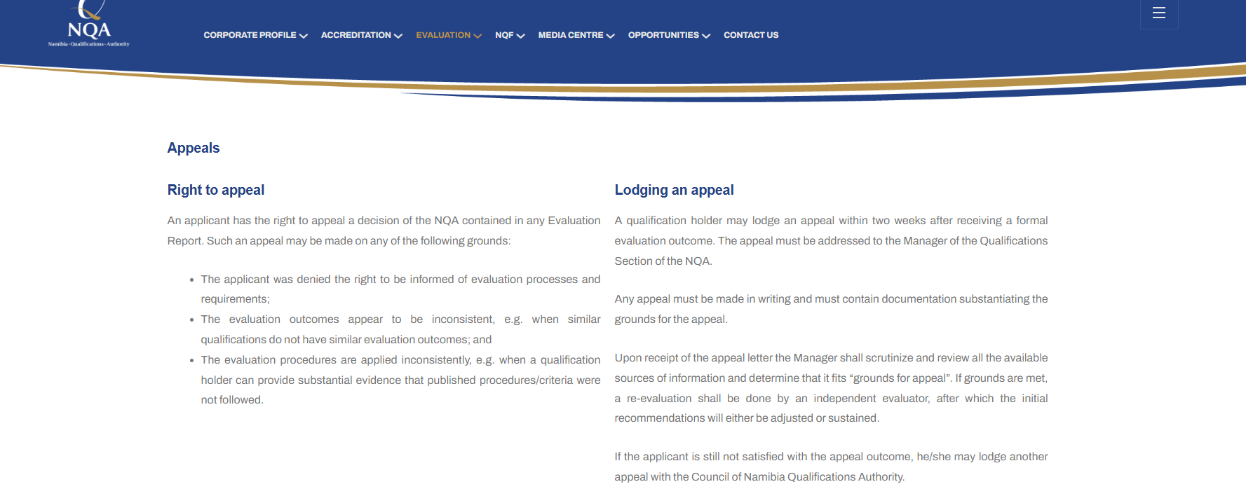
Figure 25

  - APPEAL FORM

- Click Apply to go to the appeal form

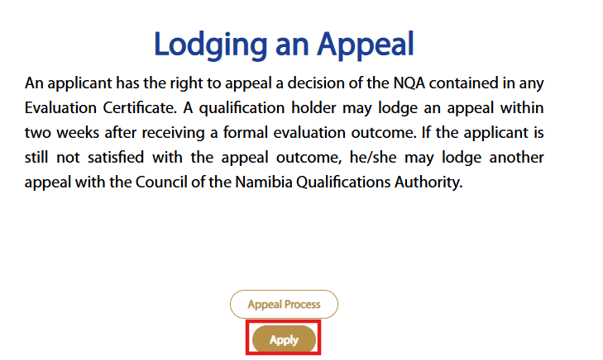
Figure 26

- Click the search icon to select the Application Evaluation ID

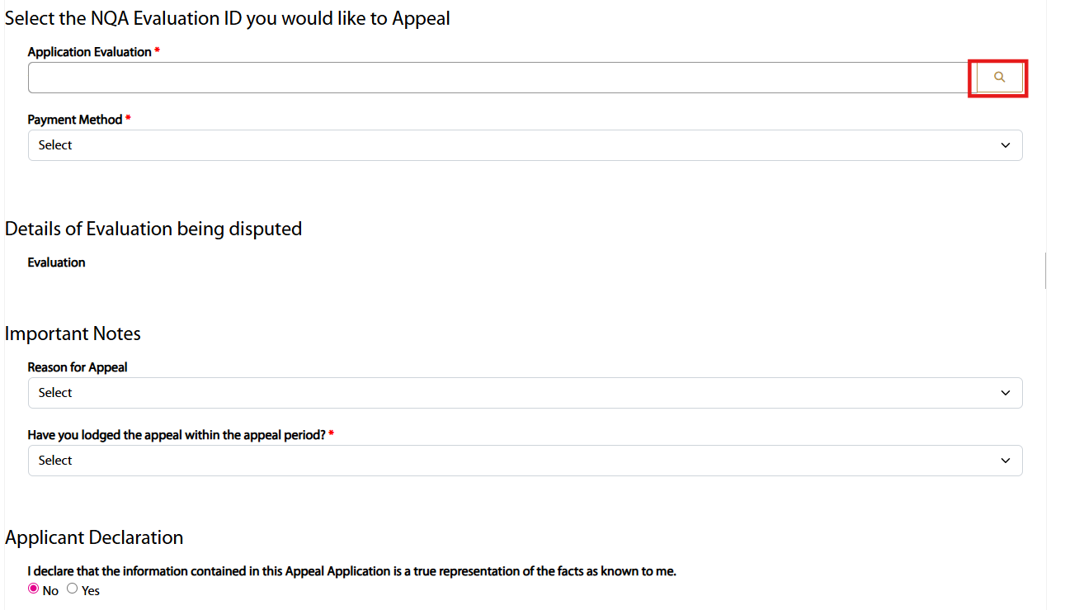
Figure 27

- Select the Evaluation ID for the appeal and click Select

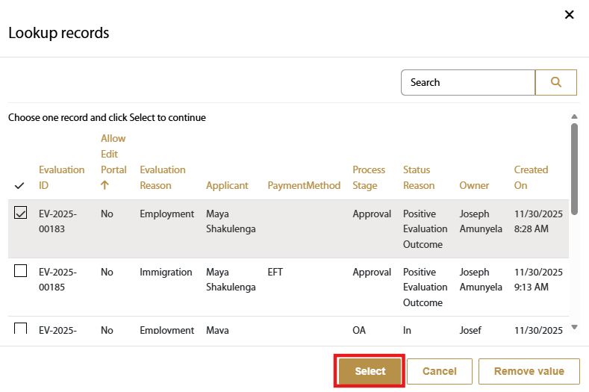
Figure 28

- When selecting the Evaluation ID, all the details of that evaluation will populate

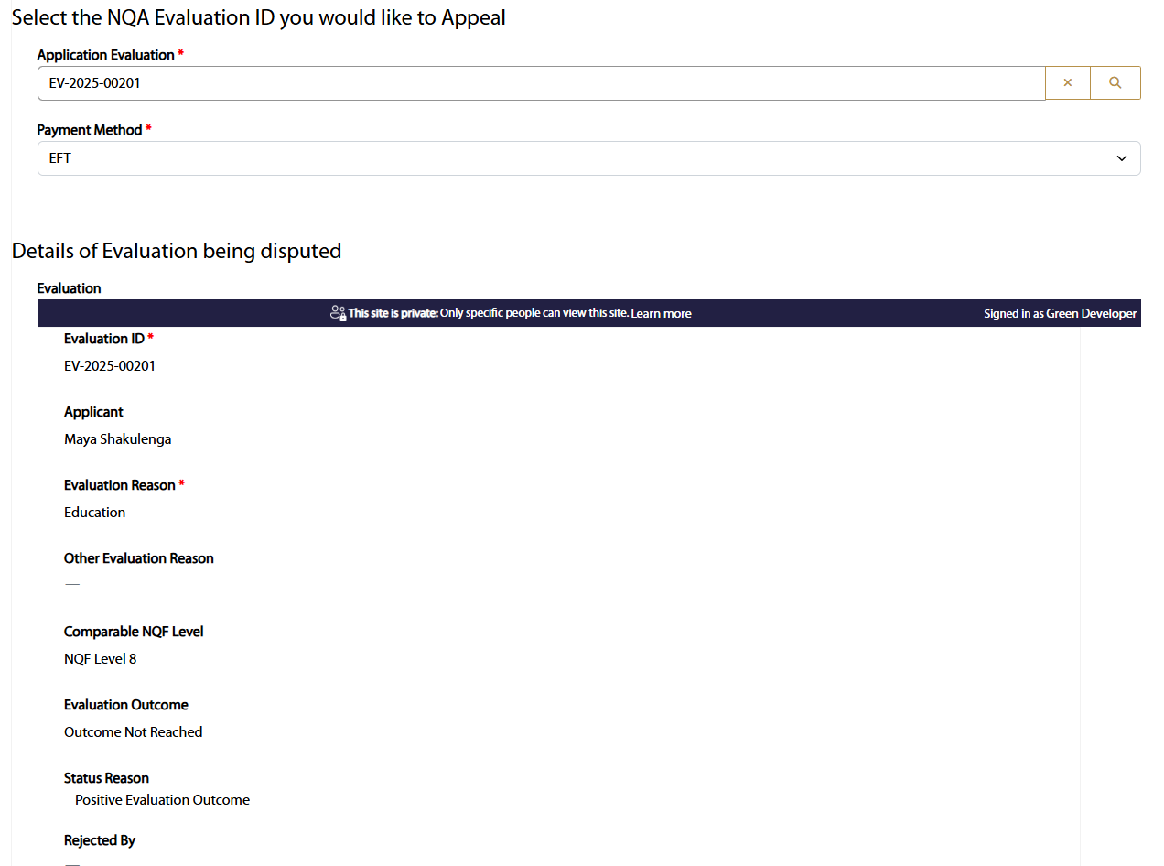
Figure 29

- Fill in the required fields and Click Submit

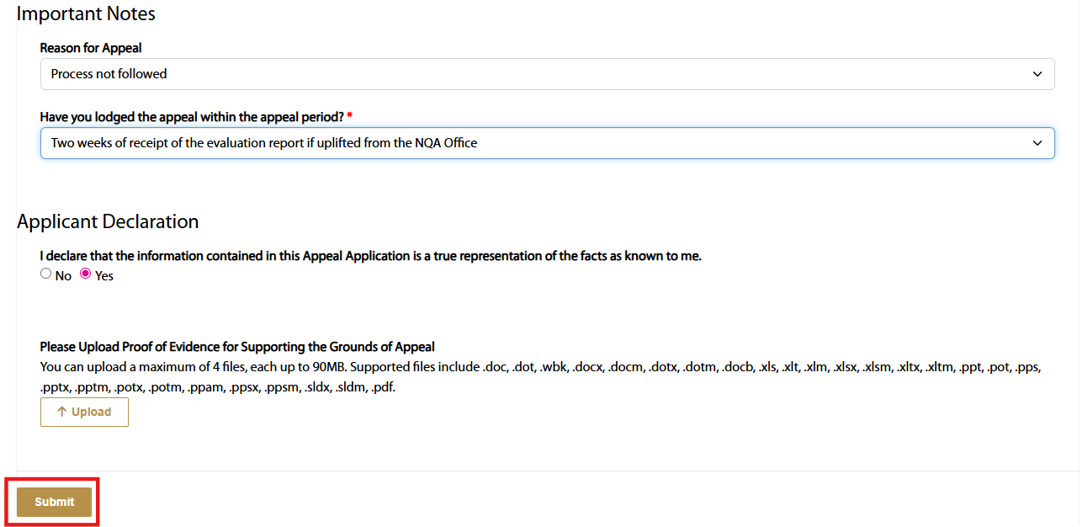
Figure 30

  - MY APPLICATIONS

- Click the My application dropdown and Select Appeals

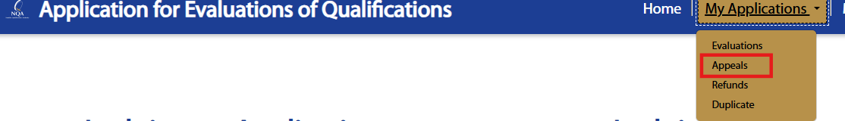
Figure 31

- View the Application status and click the View icon

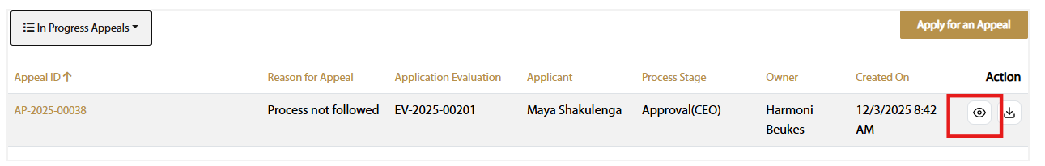
Figure 32

- View the Details of the Evaluation

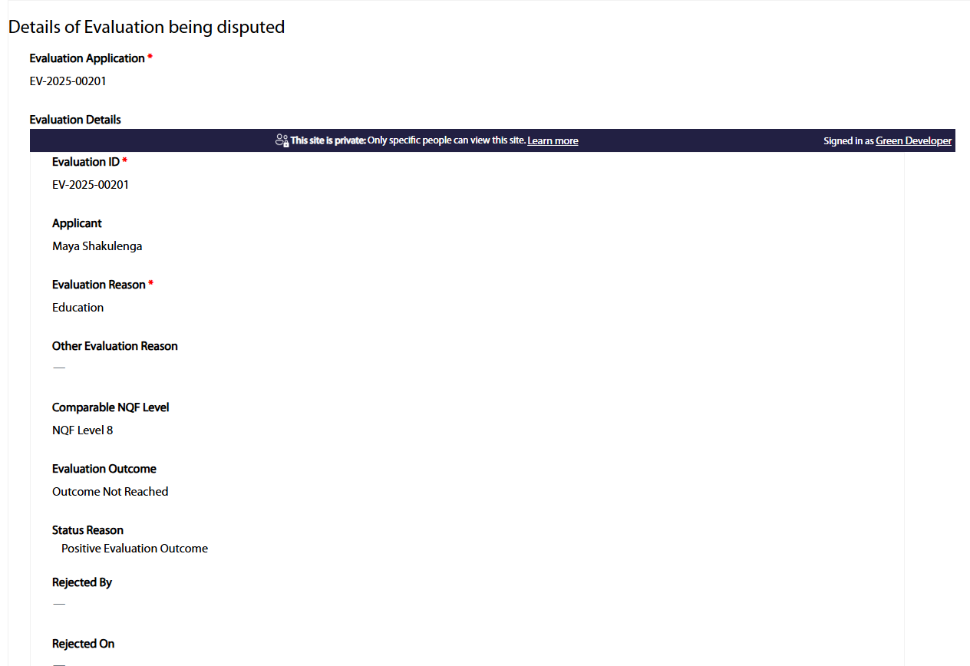
Figure 33

Note: If the appeal is approved, the certificate will be updated. If the appeal is rejected, the original evaluated certificate will remain unchanged.
- If the appeal is approved, click the download icon to generate a certificate

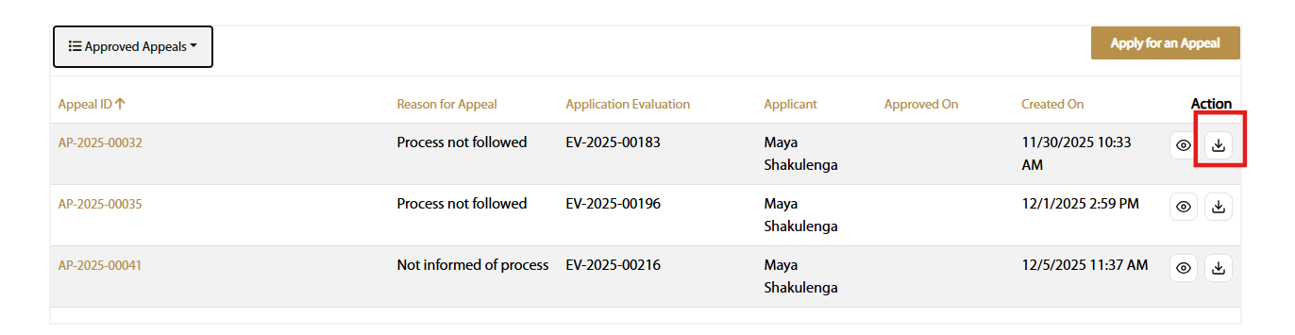
Figure 34

- Click the drop-down arrow to select the appeal category “(In Progress Appeals, Approved Appeals, or Rejected Appeals).”

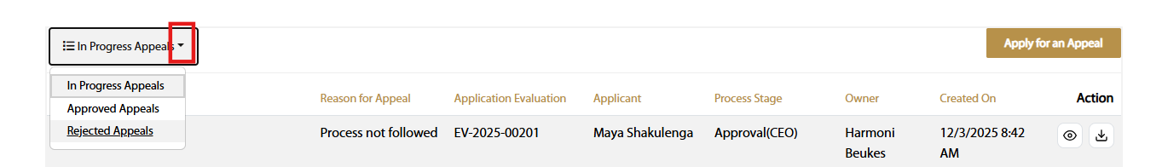
Figure 35

- REFUNDS

- Click the My application dropdown and Select Refunds

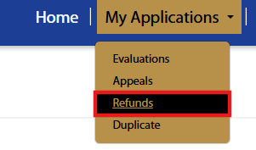
Figure 36

- Click Apply for Refund

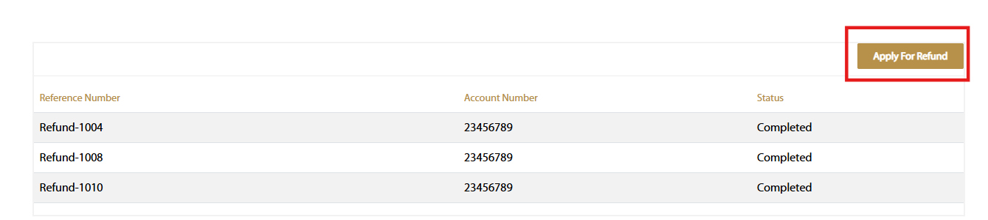
Figure 37

- Fill in the required fields and Click Submit.
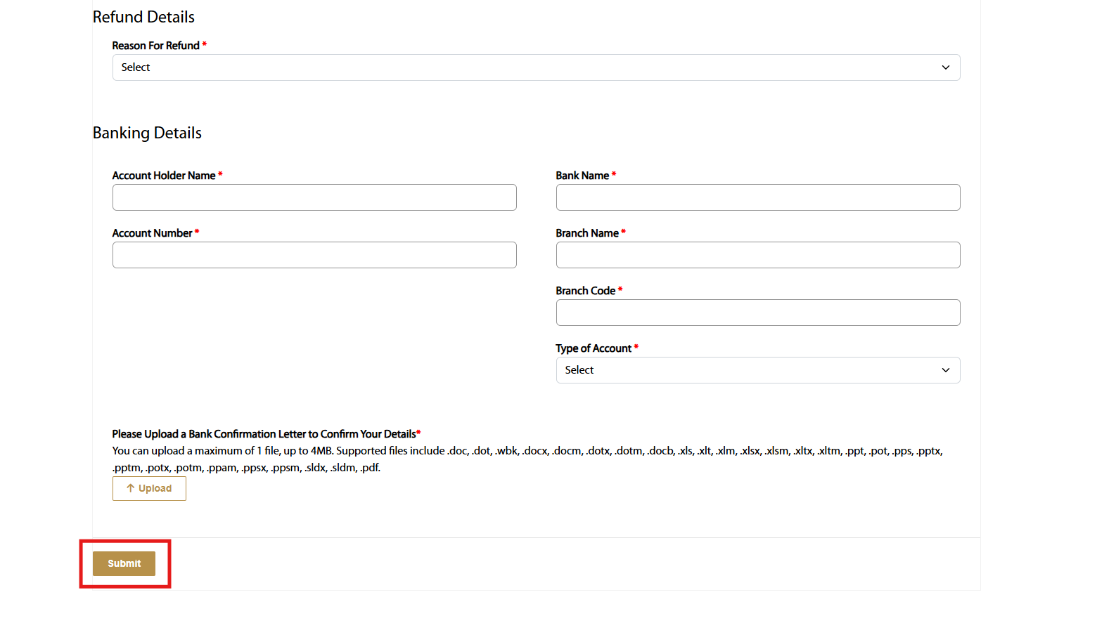
Figure 38

- View the Refund application and await the status to be “completed” to get the refunded money.

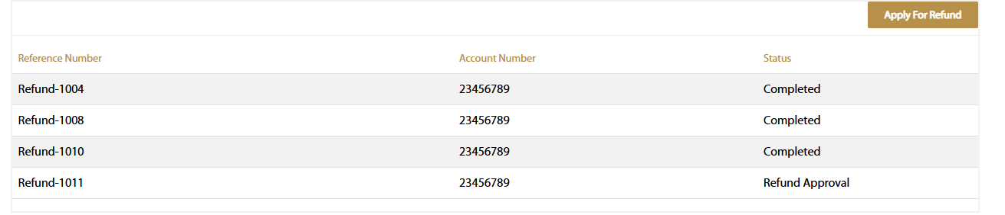
Figure 39

- DUPLICATE

- Click the My application dropdown and Select Duplicate

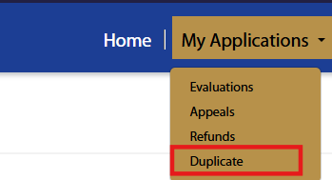
Figure 40

- Click Apply for Duplicate

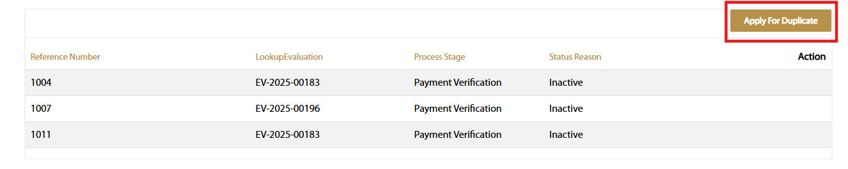
Figure 41

- Click the search icon to select the existing Evaluation ID

Figure 42

- Select the Evaluation ID and Click Select.

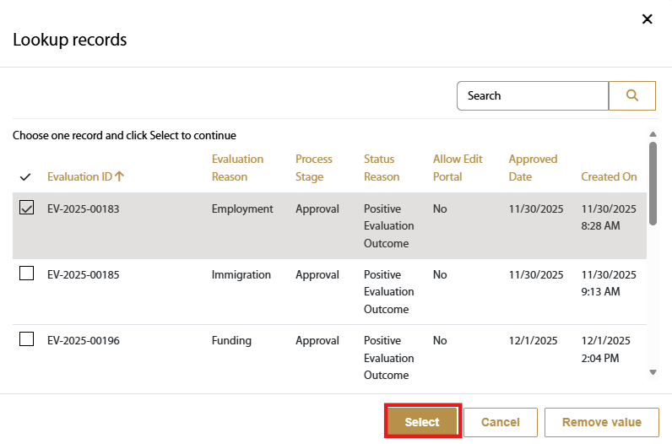
Figure 43

- Attach the following documents required and Click Submit.

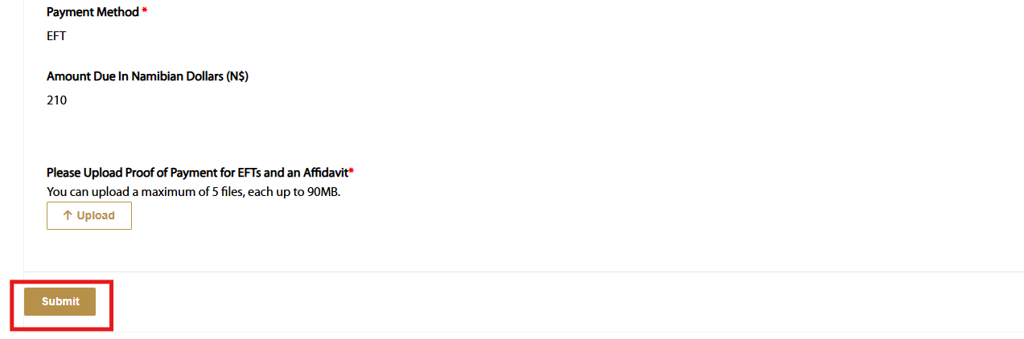
Figure 44

- View the Duplicate application and await the status and Click the download icon to generate the E-certificate.

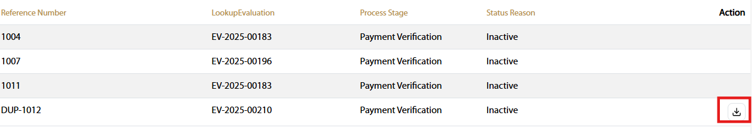
Figure 45

- PROFILE

- Click the dropdown and Select Profile

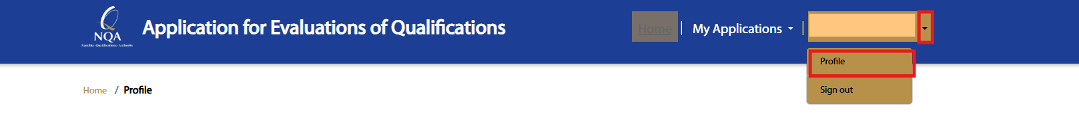

- Edit the information and Click Update when needed

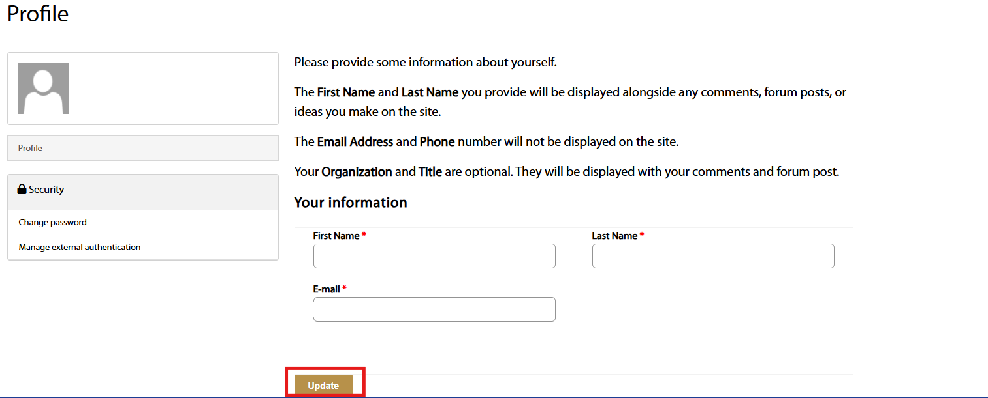
Figure 46

- In the left-hand navigation panel, Click Change password.

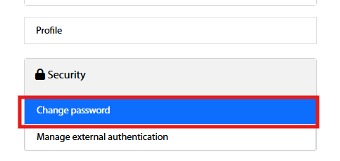
Figure 47

- To change Password, Fill in the necessary fields and Click change password

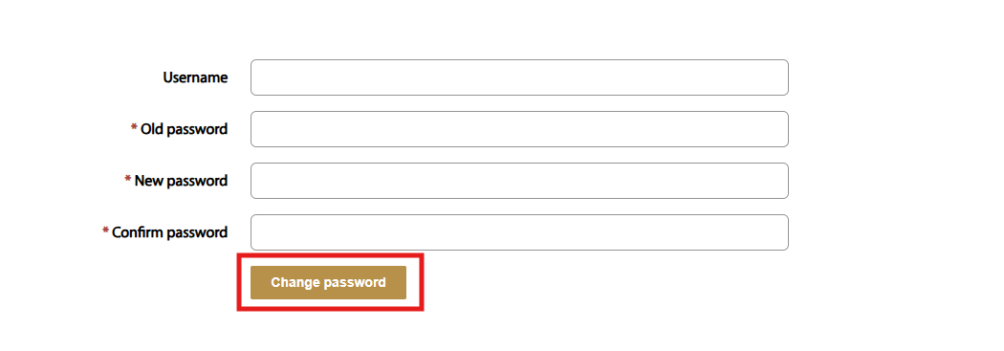
Figure 48

